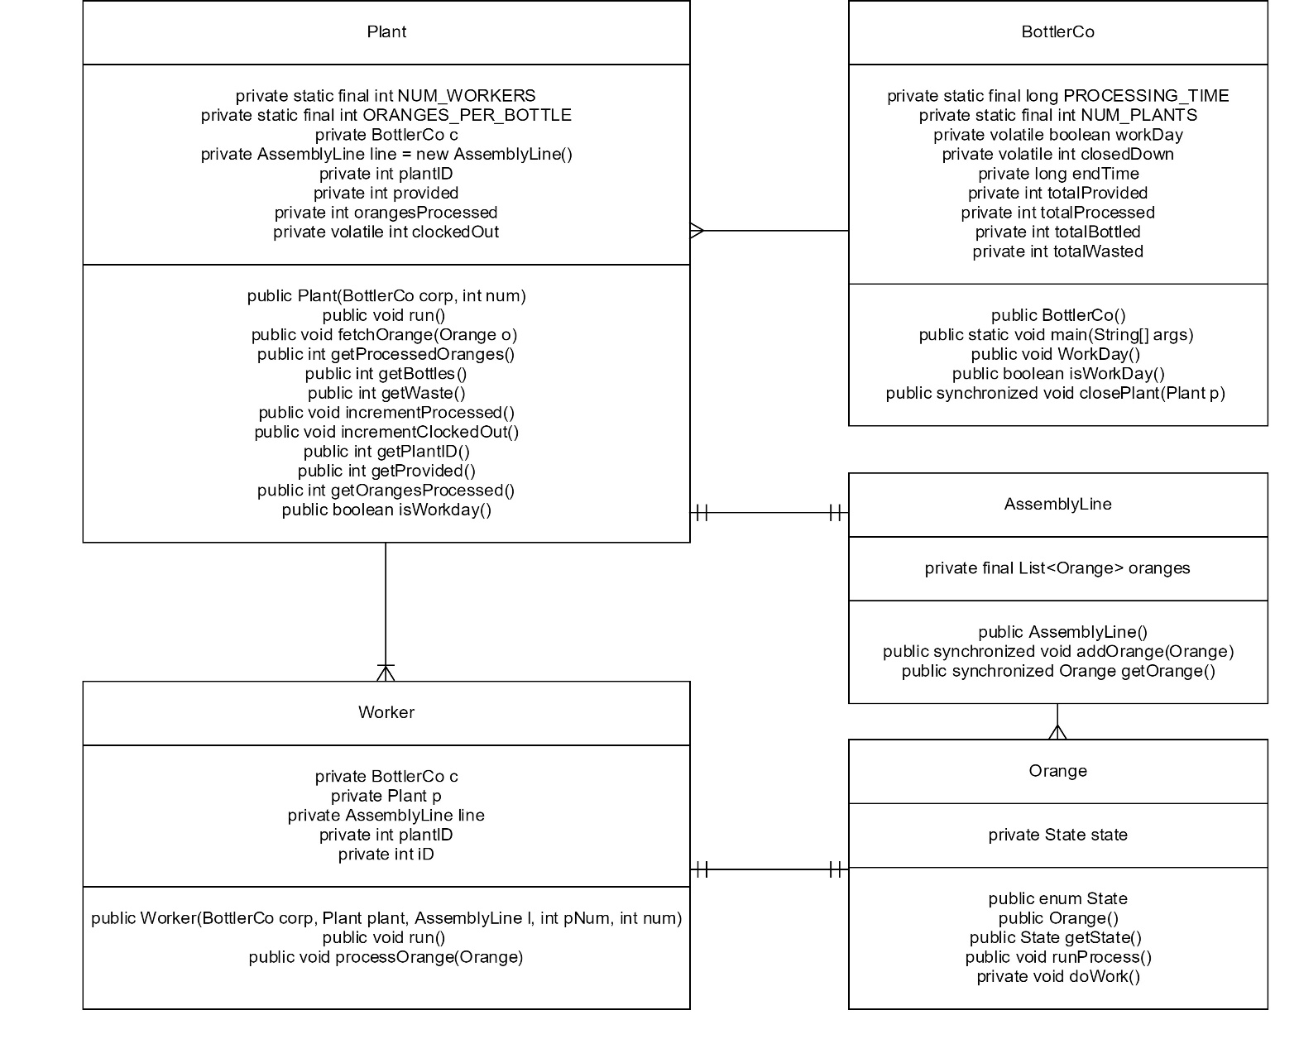I David Ross have written 100% of the code for this assignment that did not originate from you.

This Program brings up 5 plants which each produce 3 more worker threads for a total of 20/21 threads running in the program (does BottlerCo count as a thread? And if it does is it still counted since it’s done as soon as it spawns the last plant). The plants then fetch oranges and put them on the assembly line at which point the workers process them.

There was an issue where the workers were incrementing an orange as being processed at numerous times when they were not supposed to (163 oranges provided 765 processed).

At another time I was trying to use wait on a plant but it wasn’t I wasn’t able to figure out why but was able to just use a sleep(10) in a while lop to achieve the same result (though less resource efficient).

I was also confused for a while on why workers 3 and 4 were rarely if ever doing anything when I had a small number of plants.

Also made the mistake of not having BottlerCo running the main management in the beginning.